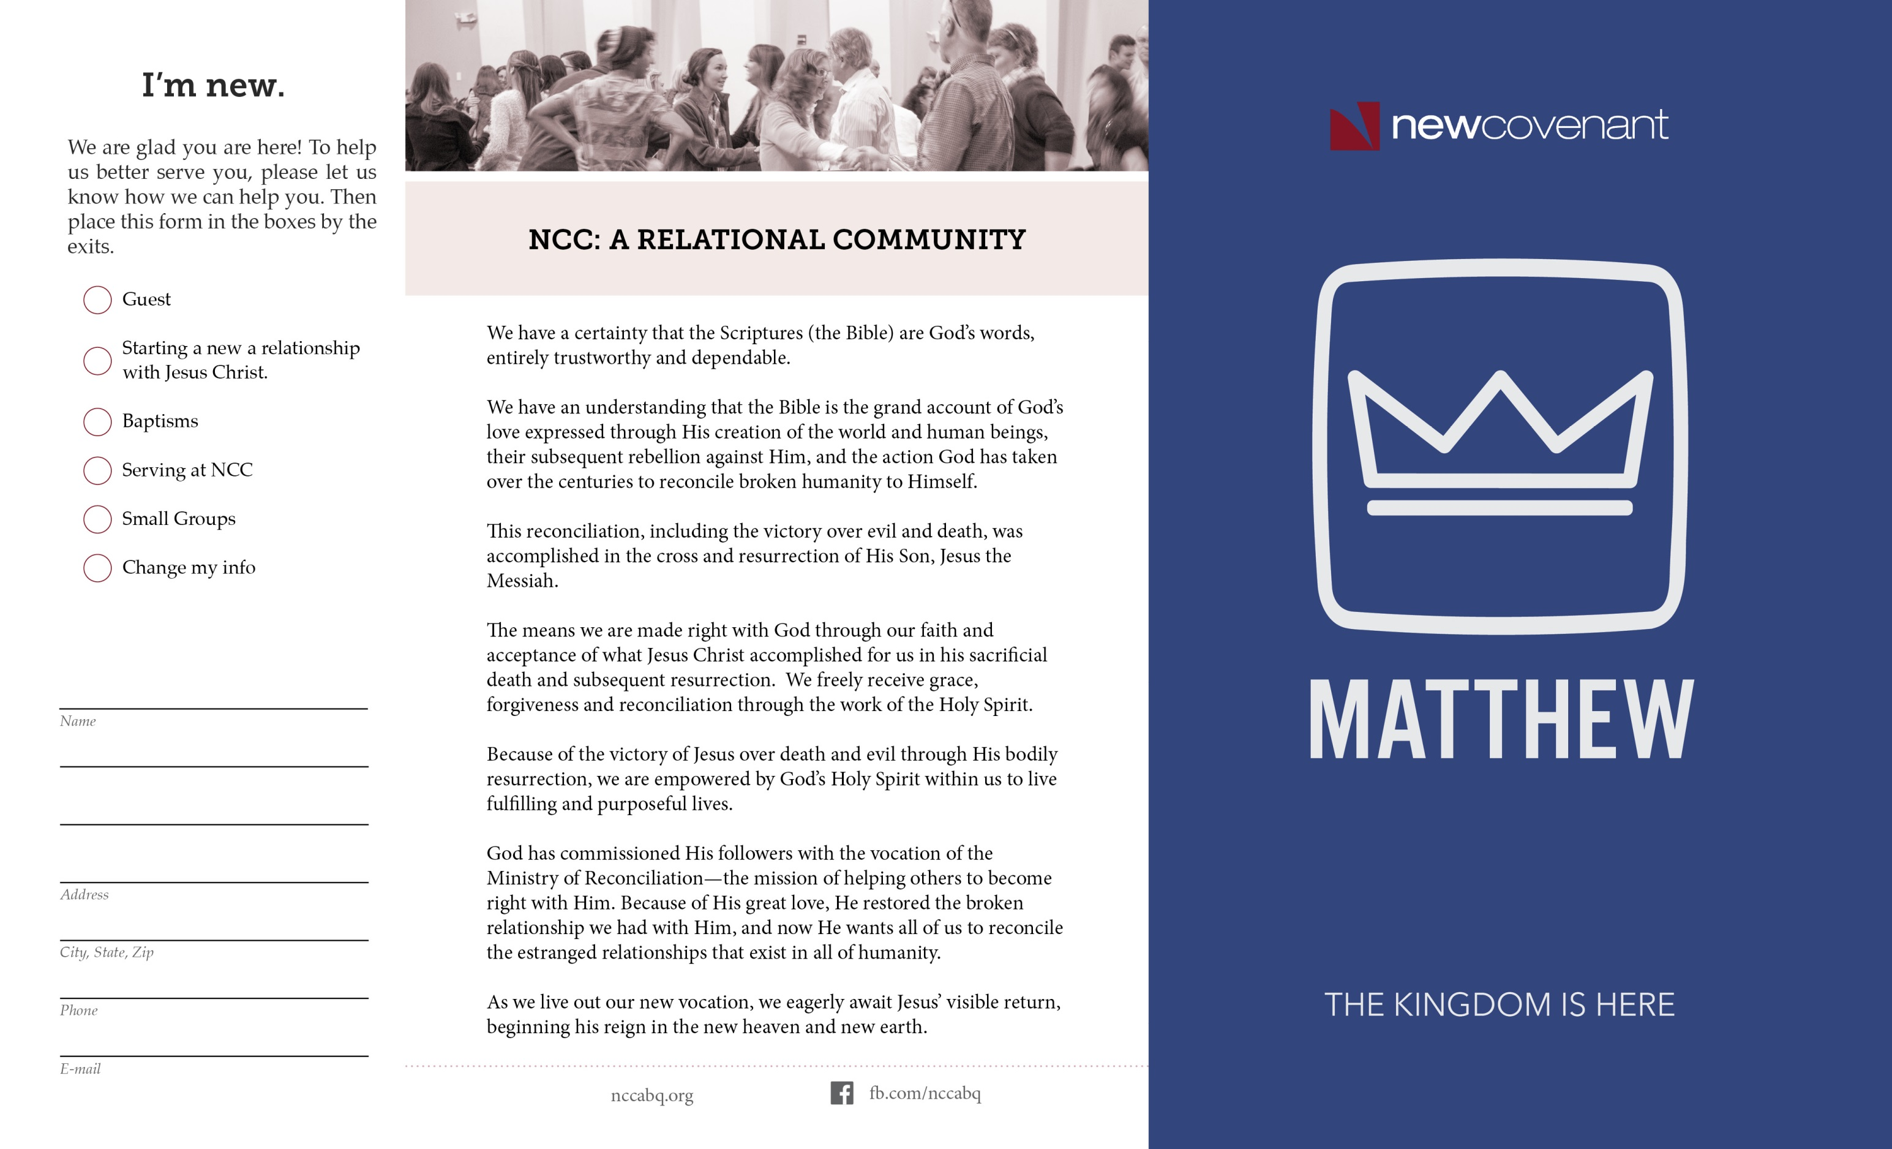

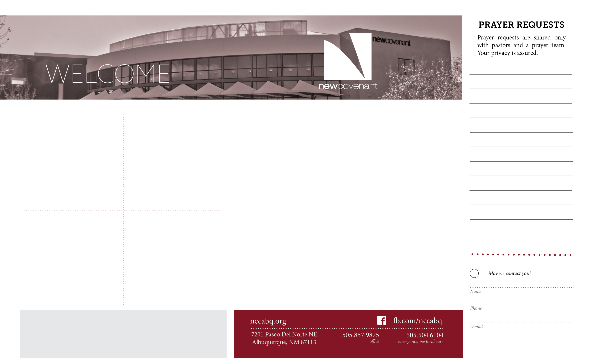

**NCC Financial Progress** Tithes & Offerings Projected $203,500

through September 20, 2015 Tithes & Offerings Given $208,937

Thank You!

Upfront with Small Groups is your chance for a casual conversation with our NCC Small group Leaders. Learn who they are, what the different groups do, and what this is all about following each service TODAY. Upfront, in the sanctuary, by the stage.

# Juntos

Juntos, (Together) reaches out to young people in the East Central area. NCC's monthly service night is tomorrow, Sept. 28 from 6:45-8. We especially need more men willing to have fun spending time with the mid-school boys.  
Come check it out! This is a simple, yet powerful way to serve

Jesus. Contact Amber Weeks at [ambeleaweeks@gmail.com](mailto:ambeleaweeks@gmail.com)

# Mom’s Cafe

There is a new mom’s group meeting at NCC. Mom's Cafe is a time for women to connect, laugh, cry, pray and support each other in the journey of motherhood. We look forward to seeing you October 7 at 10:00am in the Foyer. Childcare will be provided.

For more information contact Anna Adkins at annaadkins@nccabq.org

# Upfront with Small Groups

# Living Hope

Often when we suffer great loss, we feel we must face it alone! Our Living Hope Ministry helps people deal with the feelings and effects of life changing situations like job loss, chronic illness, death and divorce. During those times, we all need Living Hope! Bible-based grief counseling, prayer and spiritual support is available. Contact Pastor Clarke at

clsherer@gmail.com or 377-5828

# NCC Pastors & Staff

David Adkins, Executive Pastor [davida@nccabq.org](mailto:davida@nccabq.org)

Scott Bennefield, Associate Pastor [scottb@nccabq.org](mailto:scottb@nccabq.org)

Donna Daniello, Preschool Coordinator donnad@nccabq.org,

Jonathan Fortney, Midschool Director [jonf@nccabq.org](mailto:jonf@nccabq.org)

Jim Meyer, Assoc. Pastor of Worship [jimm@nccabq.org](mailto:jimm@nccabq.org)

Denver Miller, Associate Pastor [denverm@nccabq.org](mailto:denverm@nccabq.org)

Chris Olson, Associate Pastor [chriso@nccabq.org](mailto:chriso@nccabq.org)

Brandon Robinson, High School Director brandonr@nccabq.org

Dave Row, Senior Pastor sermonmonk@nccabq.org

Rose Saenz, Office Coordinator roses@nccabq.org

Reinhart Schelert, Counseling Pastor [reinharts@nccabq.org](mailto:reinharts@nccabq.org)

Clarke Sherer, Associate Pastor [clsherer@gmail.com](mailto:clsherer@gmail.com)

Chad Smitch, Associate Pastor [chads@nccabq.org](mailto:chads@nccabq.org)

Steve Stucker, Associate Pastor [steves@nccabq.org](mailto:steves@nccabq.org)

Ashlee Webb, Infant/Toddler Coordinator ashleew@nccabq.org

Type to enter text