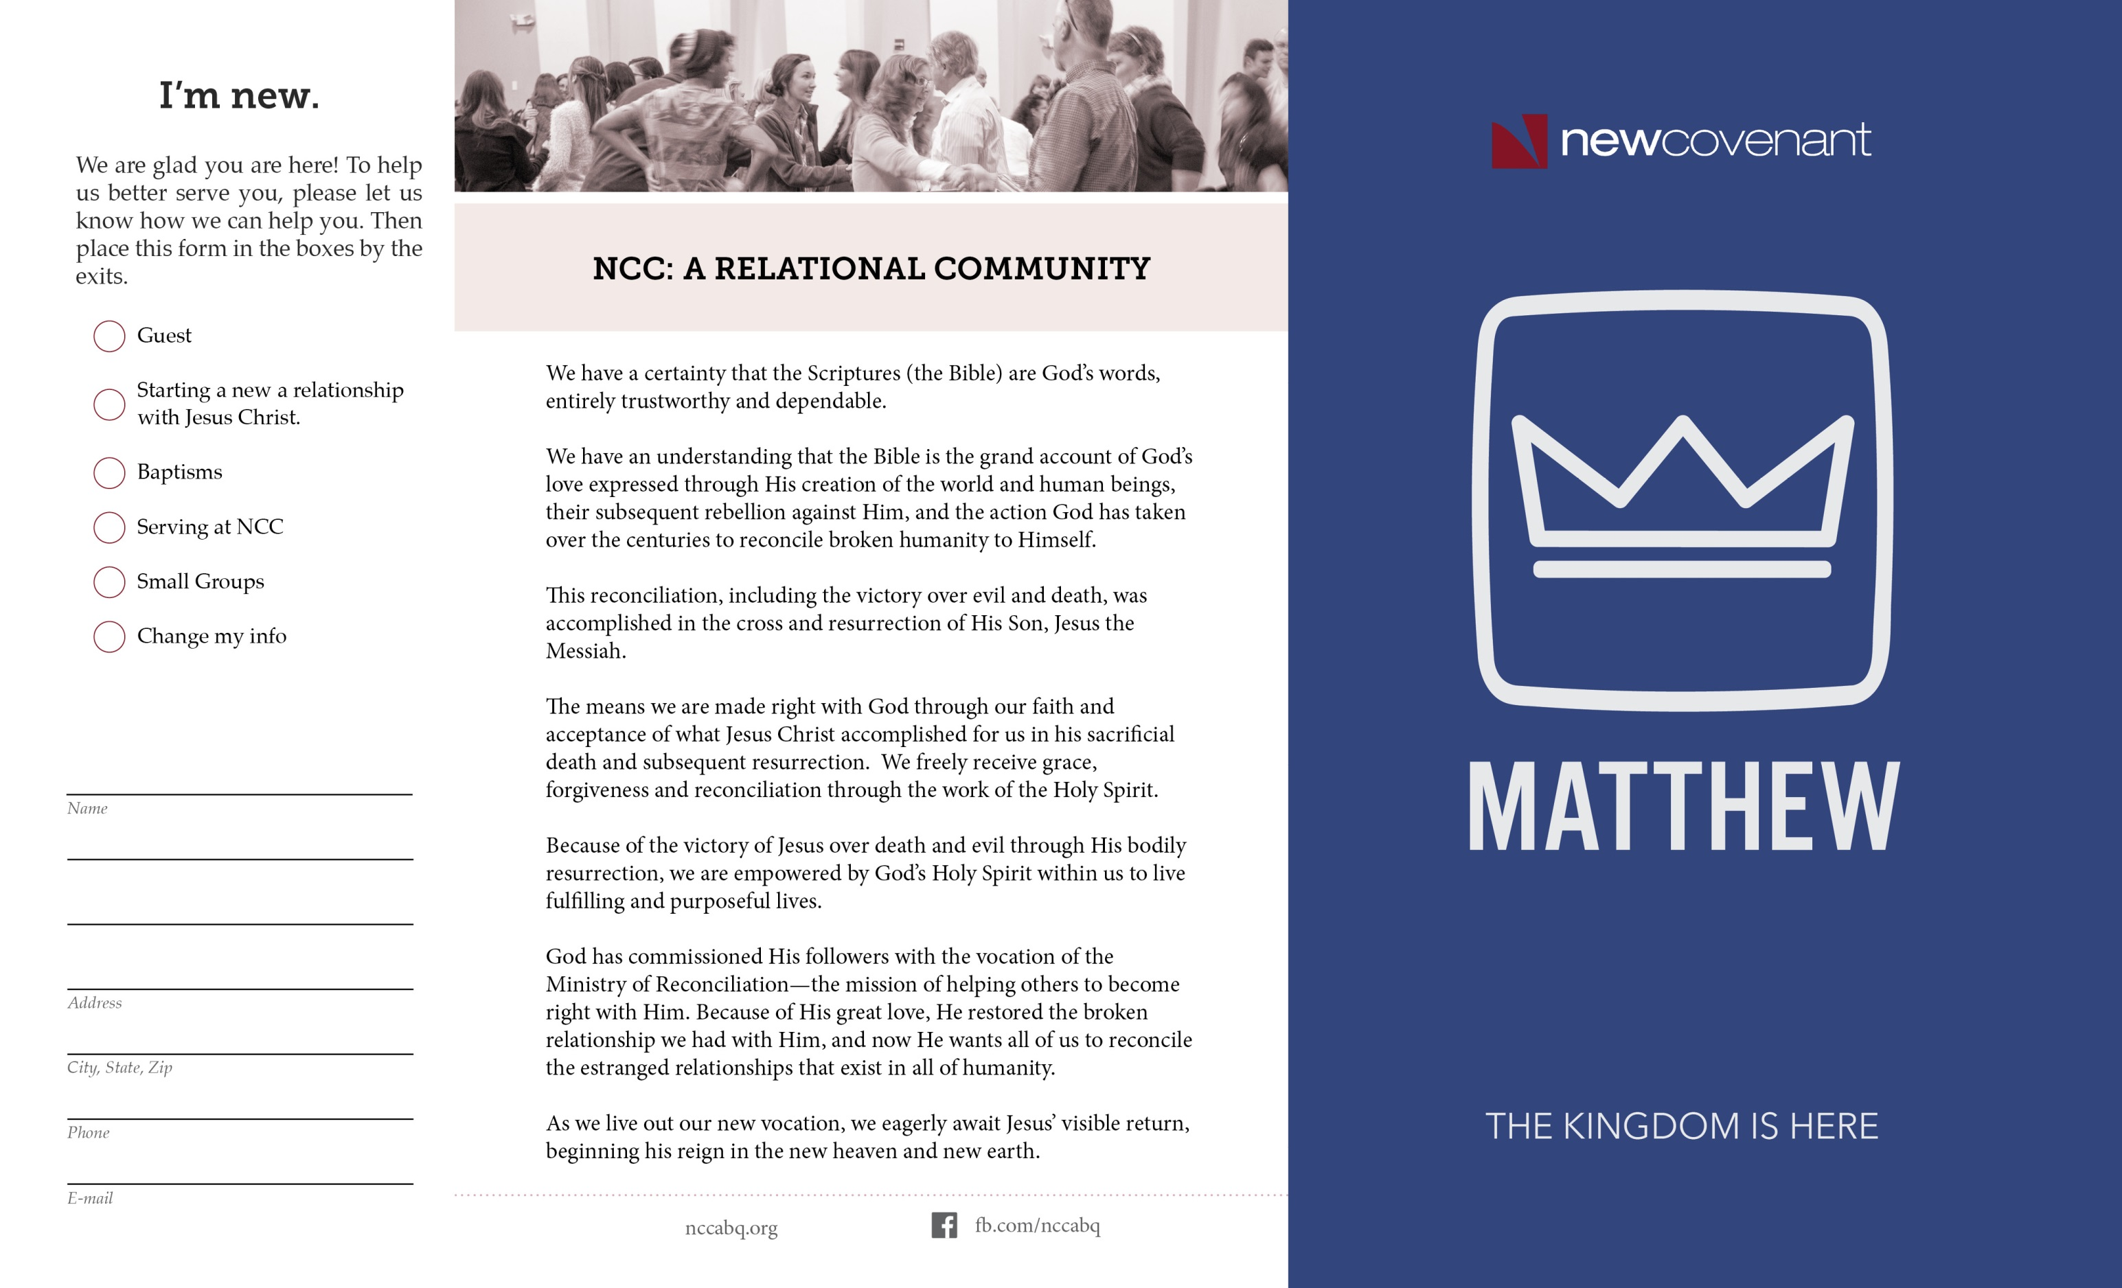

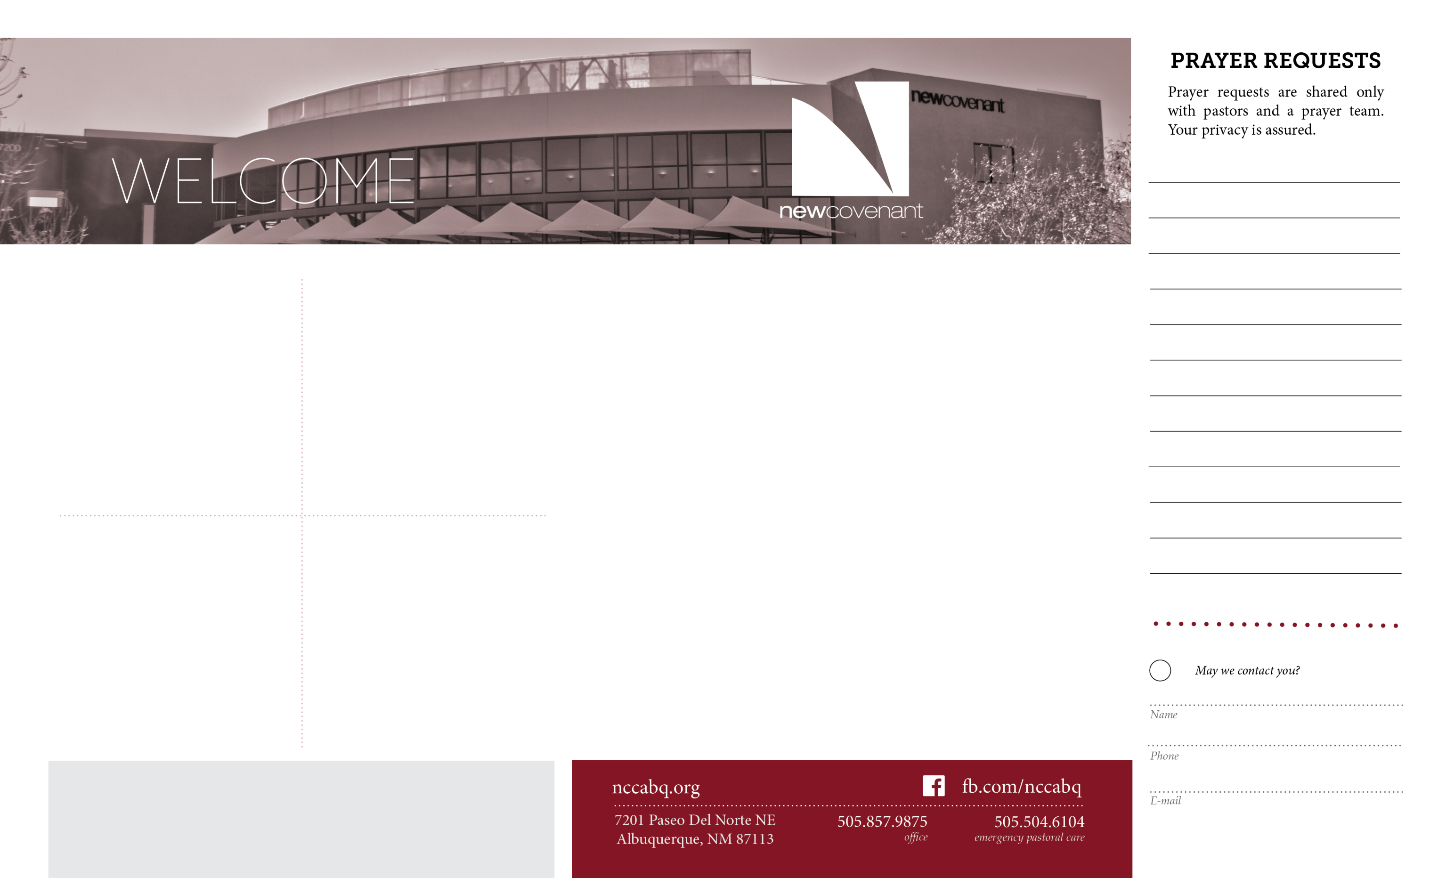

# 4th/5th Grade Hangout

THIS FRIDAY, November 20th is the next Tribe Hangout!

It’s a fun time of games, snacks and hanging out.   
Make sure your 4th are 5th graders are here! Join us from   
6:30-8:30 in the WAREHOUSE.

# Friends for Life Prison

# Ministry

**Feast Of Pies and**

**Prayer and Worship Night!**

**Our Prayer and Worship hour will be dedicated to giving thanks for all our blessings followed with Lots Of Pie! Join us November 18 at 6:30 and bring your favorite pie to share.**

Prayer and Worship Night

# http://2.bp.blogspot.com/-dKn8UHpradI/UpQPpRPznrI/AAAAAAAAE2I/l6Tiv4vvsSk/s1600/8f100aa32b1f7f4451607931ffaeca4f.jpg

Friends for Life works to change the hearts of prisoners, & changes lives in the process!  
Learn how you can sponsor a Christmas Care Packet, and/or volunteer to help these inmates with God's Word. See Don Compton in foyer after service today, or call [505-479-4774](tel:505-479-4774).

# Men’s Monthly Meeting

No Perfect Men Allowed...all others welcome!  This great group of authentic guys, get together this Saturday morning, from 8-9:30, to help put God's Word to work in our homes! Live worship, free coffee and donuts, a lesson from Pastor Steve Stucker, and small group discussion are waiting for you.

# Food Pantry-Thanksgiving

As the holidays approach, the need for our Food Pantry will skyrocket! Please start early, by bringing in your non-perishable foods and household items each week. Frozen foods, **including turkeys** are always greatly needed. Help us ensure every family at NCC has plenty to eat and be thankful for this season!

**NCC Financial Progress** Tithes & Offerings Projected $352,000

through November 15, 2015 Tithes & Offerings Given $340,694

Thank You!

Type to enter text