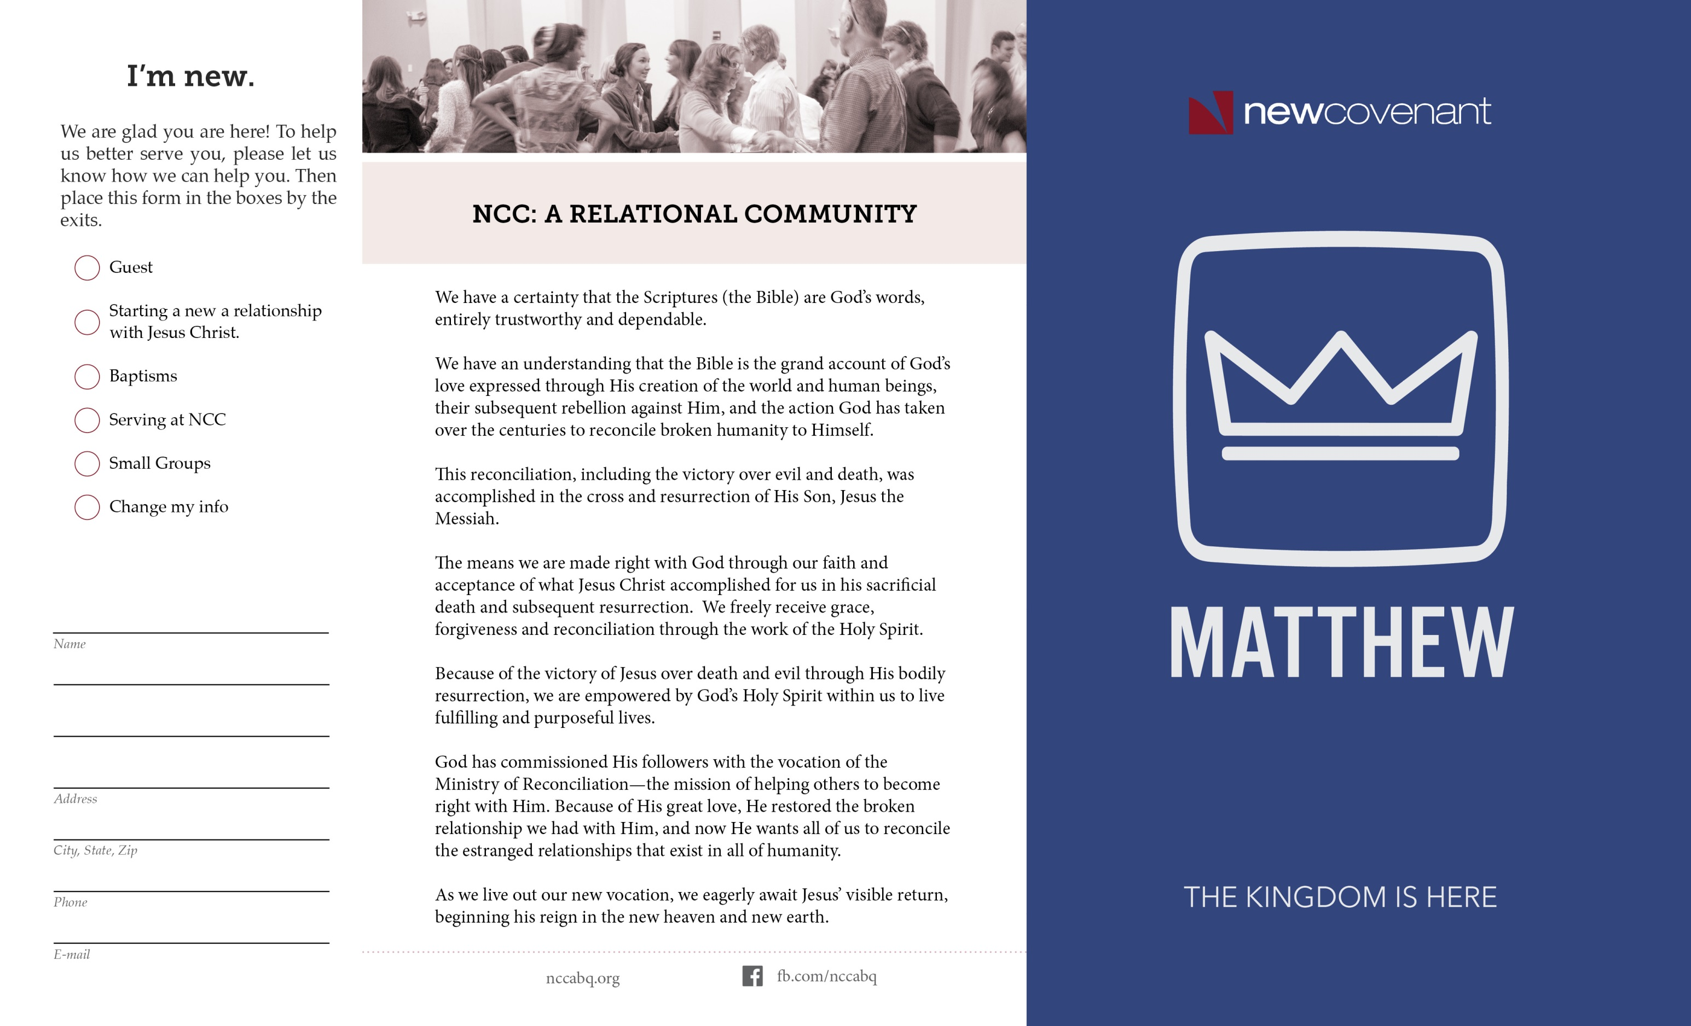

# NCC Pastors & Staff

# Upfront with Small Groups

We will host “Making NCC Your Home” following BOTH of the morning worship services TODAY, September 13! This brief session is designed to assist you to take the next step in being “all in” and connected at NCC. Join us in the Chapel.

Upfront with Small Groups is your chance for a casual conversation with our NCC Small Group Leaders. Learn who they are, what the different groups do, and what this is all about after service TODAY,

Upfront in the sanctuary by the stage.

Mark your planner now for this evening of prayer and worship. Wednesday, September 23 from 6:30-7:30. *It's a beautiful thing, and we'd love for you to join us.*

The NCC Prayer Ministry is here for you! Email prayer requests to prayer@nccabq.org, or fill out the perforated form attached to the bulletin and drop in the offering boxes.

David Adkins, Executive Pastor [davida@nccabq.org](mailto:davida@nccabq.org)

Scott Bennefield, Associate Pastor [scottb@nccabq.org](mailto:scottb@nccabq.org)

Donna Daniello, Preschool Coordinator [donnad@nccabq.org](mailto:donnad@nccabq.org)

Debi Filion, Kidz Director [debif@nccabq.org](mailto:debif@nccabq.org)

Jonathan Fortney, Midschool Director [jonf@nccabq.org](mailto:jonf@nccabq.org)

Jim Meyer, Assoc. Pastor of Worship [jimm@nccabq.org](mailto:jimm@nccabq.org)

Denver Miller, Associate Pastor [denverm@nccabq.org](mailto:denverm@nccabq.org)

Chris Olson, Associate Pastor [chriso@nccabq.org](mailto:chriso@nccabq.org)

Brandon Robinson, High School Director brandonr@nccabq.org

Dave Row, Senior Pastor sermonmonk@nccabq.org

Rose Saenz, Office Coordinator roses@nccabq.org

Reinhart Schelert, Counseling Pastor [reinharts@nccabq.org](mailto:reinharts@nccabq.org)

Clarke Sherer, Living Hope Coordinator [clsherer@gmail.com](mailto:clsherer@gmail.com)

Chad Smitch, Associate Pastor [chads@nccabq.org](mailto:chads@nccabq.org)

Steve Stucker, Associate Pastor [steves@nccabq.org](mailto:steves@nccabq.org)

Want to become debt free? Want to learn how to manage the finances God has entrusted to us? Sign-up today for Dave Ramsey Financial Peace University Class starting September 22 –November 17.

Contact Don Bremner, 720-9019,

Don@ThingsOnTheWall.com

# Personal Finance Class

Thank You!

# Prayer and Worship Night

# Making NCC Your Home

Tithes & Offerings Projected *$154,750*

Tithes & Offerings Given $173,989

**NCC Financial Progress**

Through September 6, 2015

Type to enter text